

A Data Analysis Report On

**“SHOPNEST STORES SALES”**

**CAPSTONE PROJECT**

**(POWER BI)**

**BY – Tushar Lugaria**

**Submitted to:**

**TEAM SKILLOVILLA**



**CONTEXT**

**Introduction:**

* **Data-Driven Culture**: Emphasize ShopNest's commitment to fostering a data-driven culture, where insights derived from data analytics are integral to strategic planning and daily operations.
* **Technological Integration**: Highlight the integration of advanced analytics and machine learning techniques to stay ahead of the competition and meet evolving customer demands.

**Purpose of the Analysis:**

* **Strategic Planning**: Outline how the analysis will contribute to long-term strategic planning and alignment with market trends.
* **Customer Insights**: Detail the focus on understanding customer behavior, preferences, and trends to enhance personalized marketing and customer satisfaction.
* **Operational Efficiency**: Describe how the analysis will identify inefficiencies and propose solutions to streamline operations, reduce costs, and improve overall productivity.

**Scope of the Analysis:**

* **Sales and Revenue Analysis**: Include a detailed examination of sales trends, revenue patterns, and profit margins across different product categories and regions.
* **Customer Segmentation**: Analyze customer demographics, purchasing behavior, and loyalty to tailor marketing strategies and improve customer retention.
* **Inventory Management**: Assess inventory levels, turnover rates, and stockouts to optimize inventory management and reduce holding costs.
* **Marketing Effectiveness**: Evaluate the performance of various marketing campaigns and channels to determine the most effective strategies for customer acquisition and retention.
* **Customer Feedback**: Analyze customer reviews and feedback to identify areas for improvement and enhance the overall customer experience.

**Methodology Overview:**

* **Data Sources**: Provide a comprehensive overview of the data sources used, including transactional data, customer data, and external market data.
* **Data Preprocessing**: Detail the steps taken to clean, preprocess, and transform the data for analysis, ensuring accuracy and reliability.
* **Advanced Analytics Techniques**: Mention the use of predictive analytics, clustering, and other advanced techniques to uncover hidden patterns and trends.
* **Iterative Process**: Highlight the iterative nature of the analysis, involving continuous refinement and validation of insights to ensure robustness.
* **Collaboration**: Emphasize collaboration with key stakeholders to ensure the analysis addresses their specific needs and business goals.

**Expected Outcomes:**

* **Actionable Insights**: Provide specific examples of the actionable insights expected from the analysis, such as identifying high-performing product categories or optimizing delivery routes.
* **Performance Metrics**: Define key performance metrics that will be used to measure the success of the recommendations, such as increased sales, improved customer satisfaction scores, and reduced delivery times.
* **Scalability**: Discuss the scalability of the analytical framework to accommodate future growth and evolving business needs.
* **Competitive Advantage**: Explain how the insights gained will give ShopNest a competitive edge in the market by enabling proactive decision-making and innovation.
* **Continuous Improvement**: Stress the importance of establishing a continuous improvement cycle based on ongoing data analysis and feedback loops.

**RATING DISTRIBUTION BY ORERS**

**Question Statement:**

1. Identify the rating distribution in the Shop_Nest dataset, showcasing ratings categorized as Excellent, Very Good, Good, Bad, and Very Bad, along with corresponding orders.

**Visualization:**

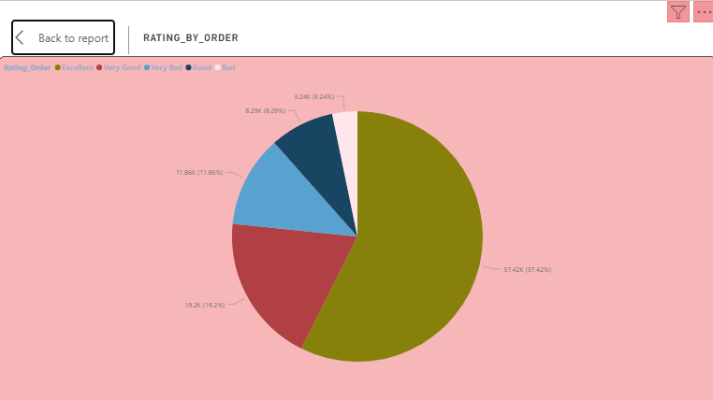

**Explanation:**

The pie chart displays the distribution of review scores given by customers for different order IDs. The ratings are categorized into five groups: 5-Excellent, 4-Very Good, 3-Good, 2-Bad, and 1-Very Bad. The chart illustrates the percentage of reviews falling into each of these categories, providing insights into customer sentiment towards ShopNest's products or services.

**Detailed Analysis:**

1. **High Customer Satisfaction**:
   * **Excellent Ratings (57.42k)**: The majority of customers (57.42k) have rated their experience as Excellent, indicating a strong level of satisfaction with ShopNest's services. This high percentage suggests that the company is consistently meeting or exceeding customer expectations.
   * **Very Good Ratings (19.2k)**: A significant number of customers (19.2k) have given a Very Good rating, further reinforcing the positive sentiment and high satisfaction levels among customers.
2. **Moderate Satisfaction**:
   * **Good Ratings (8.29k)**: A portion of customers (8.29k) have rated their experience as Good, indicating satisfaction with the services provided but also highlighting potential areas for enhancement to elevate their experience to the Very Good or Excellent level.
3. **Areas for Improvement**:
   * **Bad Ratings (3.24k)**: A smaller group of customers (3.24k) have rated their experience as Bad. This feedback is crucial for identifying specific issues that need to be addressed to prevent dissatisfaction.
   * **Very Bad Ratings (11.86k)**: While a minority, the Very Bad ratings (11.86k) indicate areas where significant improvements are necessary to enhance customer satisfaction and loyalty.

**Insights and Recommendations:**

1. **Positive Sentiment**:
   * The data indicates that the majority of ShopNest's customers are highly satisfied, with over 57.42k giving an Excellent rating. This positive feedback is a strong indicator of customer loyalty and can be leveraged in marketing campaigns to attract new customers.
2. **Addressing Negative Feedback**:
   * Despite the overall positive sentiment, the presence of Bad and Very Bad ratings highlights the need for continuous improvement. ShopNest should actively engage with dissatisfied customers to understand their concerns and take corrective actions. Implementing a robust feedback mechanism can help address these issues promptly.
3. **Focus on Continuous Improvement**:
   * To maintain and improve high satisfaction levels, ShopNest should continuously monitor and analyze customer feedback. Regular training for staff, improving product quality, and enhancing service delivery can contribute to better ratings and overall customer experience.
4. **Enhancing Customer Loyalty**:
   * Satisfied customers are more likely to return and recommend ShopNest to others. The company can implement loyalty programs, personalized offers, and rewards to further strengthen customer relationships and encourage repeat business.
5. **Resource Allocation**:
   * The insights from the pie chart can guide resource allocation. By understanding which areas receive lower ratings, ShopNest can prioritize improvements in those areas, whether it's customer service, product quality, or delivery processes.
6. **Diverse Payment Options**:
   * Offering a variety of payment options is crucial for catering to different customer preferences. Ensuring smooth and secure payment processes can enhance the overall shopping experience and reduce any friction during checkout.
7. **Data-Driven Decision Making**:
   * The pie chart serves as a valuable tool for decision-makers. By analyzing the distribution of customer ratings, ShopNest can make informed decisions to allocate resources effectively, prioritize process improvements, and enhance service efficiency to meet evolving customer demands and preferences.

### Conclusion:

The data suggests that ShopNest is performing well in terms of customer satisfaction, with the majority of customers being highly satisfied with the services provided. However, it also highlights the importance of addressing any issues that lead to negative ratings. By focusing on continuous improvement, addressing customer concerns, and leveraging positive feedback, ShopNest can enhance overall customer satisfaction and drive future business success.

**Question Statement:**

2. What are the top 10 and bottom 18 most popular product categories in the ShopNest dataset? Please list them based on the number of orders.

**Visualization:**

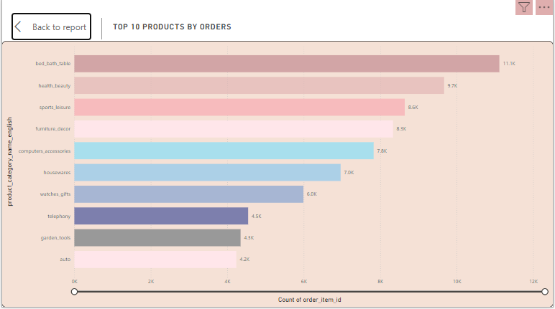

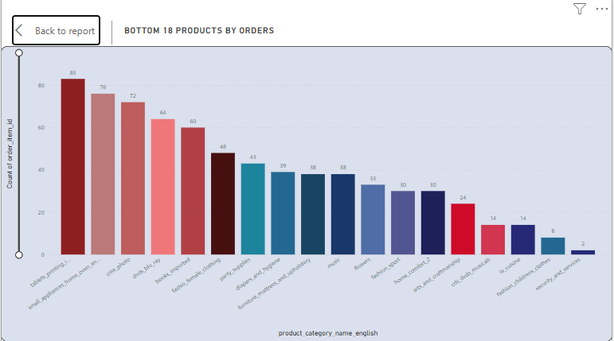

### Explanation:

The bar chart provides a comprehensive view of the top 10 most popular product categories by order count and highlights the bottom 18 categories with consistently low orders. This visualization offers valuable insights into revenue generation and customer preferences.

### Detailed Analysis:

#### Top Product Categories:

1. **Bed_bath_table (11.1K orders)**
   * **Description**: Includes bedding, bath accessories, and tableware, essential for daily living and comfort.
   * **Insights**: High demand for everyday household items signifies their importance in customer lives.
2. **Health_beauty (9.7K orders)**
   * **Description**: Encompasses healthcare products, beauty items, and personal care essentials.
   * **Insights**: Indicates a strong market for self-care and wellness products.
3. **Sports_leisure (8.6K orders)**
   * **Description**: Covers equipment, apparel, and accessories for sports and recreational activities.
   * **Insights**: Reflects the growing interest in fitness, outdoor activities, and leisure pursuits.
4. **Furniture_decor (8.3K orders)**
   * **Description**: Features furniture pieces and home decor items for indoor and outdoor spaces.
   * **Insights**: High order count highlights the demand for home improvement and decor products.
5. **Computer_accessories (7.8K orders)**
   * **Description**: Includes peripherals, components, and add-ons for computers and laptops.
   * **Insights**: Demonstrates the increasing reliance on technology and computer-related products.
6. **Housewares (7.0K orders)**
   * **Description**: Consists of practical items used for household tasks and chores.
   * **Insights**: Steady demand for essential housewares shows their necessity in everyday life.
7. **Watches_gifts (6.0K orders)**
   * **Description**: Encompasses wristwatches, accessories, and gift items.
   * **Insights**: Indicates the popularity of timepieces and gift items for various occasions.
8. **Telephony (4.5K orders)**
   * **Description**: Includes smartphones, accessories, and communication devices.
   * **Insights**: Highlights the importance of connectivity and mobile technology.
9. **Garden_tools (4.3K orders)**
   * **Description**: Features tools and equipment for gardening and outdoor maintenance.
   * **Insights**: Reflects an interest in gardening and outdoor activities.
10. **Auto (4.2K orders)**
    * **Description**: Encompasses automotive parts, accessories, and maintenance products.
    * **Insights**: Shows the ongoing need for automotive care and maintenance products.

These top product categories reflect diverse consumer preferences and needs, ranging from essential household items to specialized interests in sports, technology, and home improvement. Understanding the popularity of these categories can aid in strategic planning, marketing initiatives, and inventory management to meet customer demands effectively.

#### Bottom Product Categories:

1. **Underperforming Categories**
   * **Description**: Categories such as "tablets_printing_image", "cine_photo", and "dvds_blue_ray" consistently receive low orders.
   * **Insights**: Identifies product areas where customer interest and demand are currently lacking.
2. **Identifying Areas for Improvement**
   * **Insights**: By pinpointing low-performing product categories, businesses can gain insights into areas needing reassessment. This can lead to better product offerings and strategies to align with customer preferences.
3. **Refining Product Offerings**
   * **Insights**: Understanding which categories are not resonating with customers enables businesses to make informed decisions. This may involve discontinuing certain products, adjusting pricing strategies, or enhancing product features to better meet customer needs.
4. **Prioritizing Investments**
   * **Insights**: The bar chart helps businesses prioritize investments in product development and marketing efforts. Focusing resources on high-demand categories can optimize returns and boost overall profitability.
5. **Enhancing Customer Satisfaction**
   * **Insights**: Addressing low-performing categories can improve customer satisfaction by ensuring that product offerings align more closely with customer expectations and desires.
6. **Driving Sustained Business Growth**
   * **Insights**: Leveraging insights from the bar chart can drive sustained business growth. By concentrating on high-demand categories and making data-driven decisions, businesses can position themselves more competitively in the market and capitalize on growth opportunities.

### Conclusion:

The bar chart serves as a powerful tool for businesses to assess customer sentiment, refine product offerings, and strategically allocate resources. By understanding which product categories are underperforming, businesses can take proactive steps to improve performance, enhance customer satisfaction, and drive sustained business growth. Focusing on popular categories while addressing issues in less popular ones ensures a balanced approach to meeting customer needs and maintaining a competitive edge in the market.

**Question Statement:**

3. List the total number of active sellers by yearly and monthly.

**Visualization:**

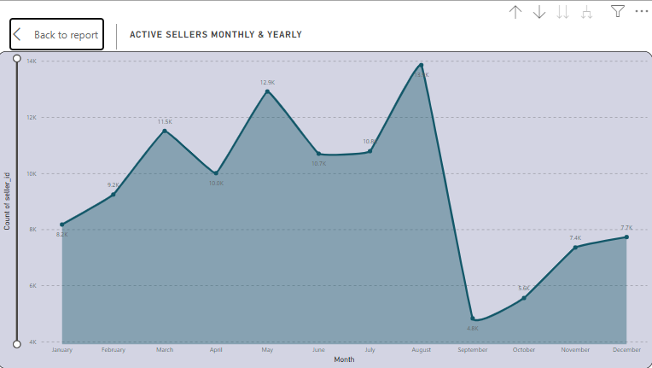

### Explanation:

The line chart depicts the number of active sellers on a monthly basis throughout a specific year. Here are the key insights and relevant points derived from the chart:

1. **Monthly Trends**:
   * **January to March**: The number of active sellers increased steadily from 8.2K in January to 11.5K in March.
   * **April to May**: There was a peak in May with 12.9K active sellers, showing a significant increase in seller activity during this period.
   * **June to September**: The active seller count experienced fluctuations, with a notable peak in August (13.6K) and a sharp decline in September (4.8K).
   * **October to December**: Post-September, the number of active sellers gradually increased again, reaching 7.7K in December.
2. **Peak Periods**:
   * **Highest Peak**: August had the highest number of active sellers at 13.6K. This peak could be attributed to seasonal trends, promotional events, or specific campaigns encouraging seller participation.
   * **Second Peak**: May also saw a significant number of active sellers, with 12.9K, indicating another period of high seller activity.
3. **Significant Decline**:
   * **September**: There was a noticeable drop in the number of active sellers, falling to 4.8K. This sharp decline might be due to seasonal factors, end-of-promotional periods, or operational challenges.
4. **Recovery Period**:
   * **October to December**: The recovery in seller activity towards the end of the year, with steady increases each month, reaching 7.7K in December, suggests a regaining of seller engagement possibly due to holiday season preparations or end-of-year promotions.
5. **Strategic Implications**:
   * **Resource Allocation**: Understanding these trends helps in planning resources more effectively, ensuring adequate support during peak periods and addressing potential issues during low activity months.
   * **Seller Engagement Strategies**: Identifying the factors behind the peaks and troughs can help in devising strategies to maintain consistent seller engagement throughout the year.
   * **Platform Enhancements**: Insights from these trends can inform decisions on platform improvements, promotional activities, and incentives to boost seller activity.
6. **Integrating Shipping Limit Data**:
   * **Operational Insights**: By integrating shipping limit data with seller counts, the platform can gain a better understanding of how logistics and operational policies impact seller engagement and marketplace performance.
   * **Strategic Adjustments**: Adjusting shipping limits based on seller activity trends can help maintain a balance between operational capacity and seller satisfaction.

**Visualization Benefits:**

* **X-axis**: Represents time, with a breakdown by month and year.
* **Y-axis**: Represents the number of active sellers.
* **Trend Lines**: Display fluctuations in seller counts, making it easy to identify peaks and troughs.

**Strategic Decision-Making:**

* **Resource Allocation**: Understanding peak periods allows for better planning and allocation of resources to support sellers effectively during high activity months.
* **Seller Engagement Strategies**: Identifying factors behind peak months helps in crafting targeted engagement strategies and promotional campaigns to sustain seller participation.
* **Platform Enhancements**: Insights from these trends can guide improvements to the platform, ensuring it remains attractive and supportive for sellers.

**Shipping Limit Data Integration:**

* **Operational Insights**: Combining shipping limit data with seller counts provides a deeper understanding of how logistics and operational policies impact seller engagement.
* **Strategic Adjustments**: Adjusting shipping limits in response to seller activity trends can help maintain operational efficiency and seller satisfaction.

**Conclusion:**

The line chart effectively visualizes the fluctuations in active seller counts on a monthly basis. Peaks in May and August, along with a significant drop in September, highlight the dynamic nature of seller activity. By leveraging these insights, platform managers can make informed decisions to enhance seller engagement, allocate resources efficiently, and drive overall marketplace growth.

**Question Statement:**

4. Which payment methods are most commonly used by ShopNest customers.

**Visualization:**

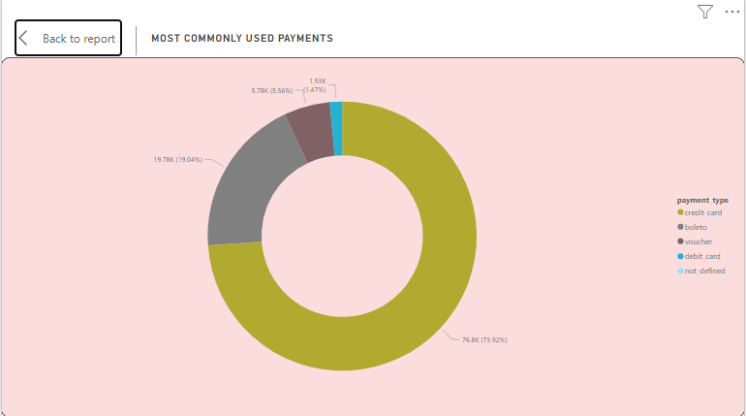

### Detailed Explanation of Payment Types Distribution:

The pie chart offers a comprehensive view of the different payment types chosen by customers and their distribution. Here are enhanced and relevant points for the explanation:

#### **Payment Type Breakdown**:

1. **Credit Card - 76,795 Customers (Approximately 73.9%)**:
   * **Dominance**: Credit cards are the most popular payment method, preferred by a substantial majority of customers.
   * **Insights**: The high usage of credit cards underscores their convenience, security, and the benefits they offer, such as rewards points, cashback, and buyer protection.
2. **Boleto - 19,784 Customers (Approximately 19.0%)**:
   * **Popularity**: Boleto is the second most preferred payment option, appealing to customers who favor bank slips.
   * **Insights**: This preference can be attributed to customers who prioritize security, prefer offline payment methods, or do not have access to credit cards.
3. **Voucher - 5,775 Customers (Approximately 5.6%)**:
   * **Usage**: Vouchers represent a smaller but significant portion of transactions.
   * **Insights**: This indicates the utilization of promotional codes or gift vouchers, highlighting the importance of marketing campaigns and loyalty programs in driving sales.
4. **Debit Card - 1,529 Customers (Approximately 1.5%)**:
   * **Fraction**: Debit card transactions form a smaller segment of the total payments.
   * **Insights**: This reflects a preference among some customers for direct deductions from their bank accounts, emphasizing the need for a secure and seamless debit card processing system.

#### Customer Preferences:

* **Convenience and Security**: The dominance of credit card payments indicates a strong preference for methods that offer convenience, security, and additional benefits.
* **Alternative Preferences**: The notable use of boleto and vouchers shows the importance of providing alternative payment methods to cater to diverse customer needs.

#### Strategic Resource Allocation:

* **Focus on Credit Card Processing**: Given the high preference for credit cards, businesses should ensure their credit card processing systems are optimized for efficiency, security, and reliability.
* **Support for Alternative Methods**: While focusing on credit cards, it is also crucial to maintain robust support for boleto, vouchers, and debit cards to cater to the preferences of all customer segments.

#### Enhancing Customer Experience:

* **Diverse Payment Options**: Offering a variety of payment methods enhances customer satisfaction by accommodating different preferences and increasing the likelihood of completing a purchase.
* **Improving Payment Processing**: Continuously improving payment processing capabilities can lead to smoother transactions, higher customer satisfaction, and reduced cart abandonment rates.

**Additional Points:**

* **Market Insights**: Analyzing payment preferences can offer insights into the demographic and geographic characteristics of the customer base, guiding targeted marketing efforts.
* **Adaptability**: Keeping an eye on emerging payment trends and being adaptable to incorporate new payment methods (e.g., digital wallets, cryptocurrencies) can help in staying ahead in the market.
* **Customer Trust**: Transparent and secure payment processes build customer trust, encouraging repeat purchases and customer loyalty.

By focusing on these enhanced points, businesses can make informed decisions to optimize their payment systems and overall customer experience.

### Conclusion:

The pie chart provides a clear snapshot of customer payment preferences, with credit cards being the most favored, followed by boleto, vouchers, and debit cards. Understanding these preferences is vital for businesses to tailor their payment strategies, enhance customer experiences, and drive operational efficiencies. By offering a range of payment options and improving processing systems, businesses can effectively meet diverse customer needs and maintain a competitive edge in the marketplace.

**Question Statement:**

5. Identify the product category. wise profit margin using the formula

Hint: (Payment value -price + Freight_value)/payment_value*100 (Rounded to two decimal points).

**Visualization:** 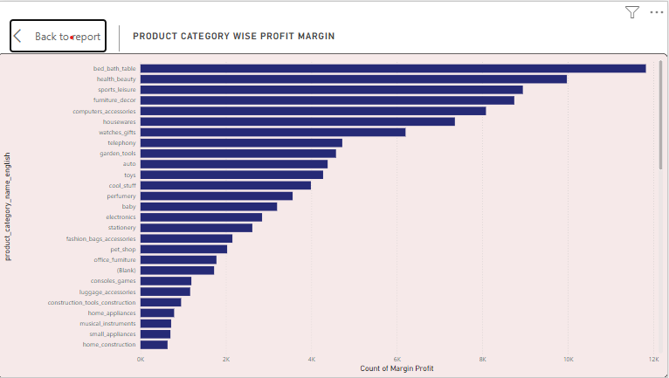

Certainly! Here are enhanced points for the explanation regarding identifying product categories based on their profit margins and visualizing this data using a bar chart:

#### **Calculation of Profit Margin:**

To calculate the profit margin, we use the formula: Profit Margin=(Payment Value−Price+Freight Value)Payment Value×100\text{Profit Margin} = \frac{(\text{Payment Value} - \text{Price} + \text{Freight Value})}{\text{Payment Value}} \times 100Profit Margin=Payment Value(Payment Value−Price+Freight Value)​×100

This formula yields the profit margin as a percentage, rounded to two decimal points.

#### **Product Category-wise Profit Margin Analysis:**

1. **Bed_bath_table - Profit Margin: 11.8k**:
   * **Highest Profit Margin**: This category demonstrates the highest profit margin, indicating efficient cost management and high sales prices relative to costs.
   * **Insights**: The profitability in this category suggests strong demand and potentially higher markups on products.
2. **Health_beauty - Profit Margin: 10.0k**:
   * **Strong Profitability**: Health and beauty products also show a strong profit margin, which could be due to high sales prices and loyal customer base.
   * **Insights**: The category’s profitability suggests opportunities for expansion and increased inventory.
3. **Sports_leisure - Profit Margin: 8.9k**:
   * **Healthy Profit Margin**: The sports and leisure category indicates a solid profit margin, reflecting effective pricing strategies and cost control.
   * **Insights**: This suggests a balanced approach to pricing and cost management, making it a viable category for further investment.
4. **Furniture_decor - Profit Margin: 8.1k**:
   * **Solid Profit Margin**: Furniture and decorative items show a respectable profit margin.
   * **Insights**: This category’s profitability suggests potential for growth in sales and inventory.
5. **Housewares - Profit Margin: 7.4k**:
   * **Respectable Profit Margin**: Housewares, including kitchen and cleaning products, maintain a decent profit margin.
   * **Insights**: The steady profitability indicates operational efficiency and effective cost management.

#### **Visual Representation: Bar Chart**

A bar chart is an effective visualization tool for comparing profit margins across different product categories:

* **X-axis**: Product Categories (e.g., Bed_bath_table, Health_beauty, Sports_leisure, Furniture_decor, Housewares).
* **Y-axis**: Profit Margin (%).

#### **Profit Margin Insights:**

* **Relative Profitability**: Analyzing profit margins by product category provides insights into which categories are more profitable.
* **Investment Opportunities**: Categories with higher profit margins indicate potential areas for further investment and expansion.

#### **Strategic Decision-Making:**

* **Informed Decisions**: Businesses can use this data to optimize pricing strategies, cost management, and resource allocation.
* **Operational Efficiency**: Identifying high-performing categories helps in focusing efforts on maximizing overall profitability.

#### **Competitive Advantage:**

* **Market Differentiation**: Understanding which product categories yield the highest profit margins allows businesses to focus on their strengths.
* **Efficiency Improvements**: Identifying less profitable categories helps in making necessary improvements in efficiency and cost-effectiveness.

### Conclusion:

Analyzing profit margins by product category using the provided formula and visualizing this data with a bar chart provides valuable insights for strategic decision-making and optimizing business performance. It enables businesses to identify high-performing categories, optimize operations, and make data-driven decisions to enhance profitability and competitive advantage.

**Question Statement:**

6. Determine the monthly payments made by customers using credit cards.

**Visualization:**

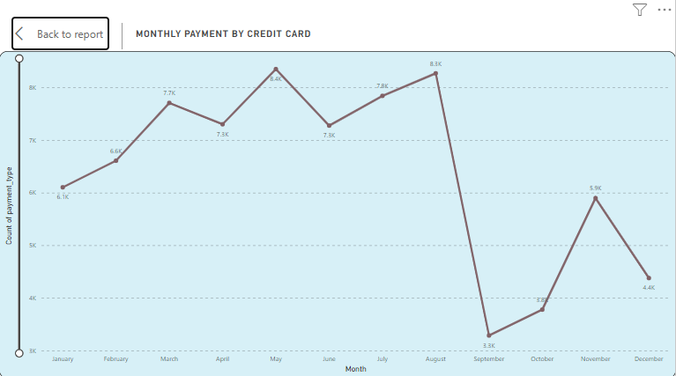

**Explanation:**

To create a line chart depicting the monthly payments made by customers using credit cards, we'll use the provided data points and visualize the trend across different months. Here’s how we can analyse and present this information effectively

**Overview**

* **X-Axis:** Represents the months from January to December.
* **Y-Axis:** Represents the count of payment types, with values ranging from 3K to 9K.
* **Line Graph:** Indicates the monthly variation in the count of credit card payments

#### **Data Points Analysis:**

* **August:** Customers Count - 10.8k (10,843)
  + **Insight:** August recorded the highest number of customers making payments using credit cards, indicating a peak in credit card transactions during this month.
* **May:** Customers Count - 10.6k (10,573)
  + **Insight:** May closely follows August with a high number of credit card transactions, suggesting strong customer usage of credit cards during this period.
* **July:** Customers Count - 10.3k (10,318)
  + **Insight:** July also shows significant credit card usage, although slightly lower compared to August and May.
* **March:** Customers Count - 9.9k (9,893)
  + **Insight:** March exhibits a substantial number of credit card transactions, indicating a consistent level of customer activity in credit card payments.
* **September:** Customers Count - 4.3k (4,305)
  + **Insight:** September marks the lowest number of customers using credit cards for payments among the specified months, suggesting a potential decrease in transaction volume during this period.

### Representing the Data Using a Line Chart

#### Chart Components:

* **X-axis:** Months (January, February, March, April, May, June, July, August, September, October, November, December)
* **Y-axis:** Number of Customers Using Credit Cards (in thousands)

### Trend Analysis:

* The line chart visually represents the trend in credit card payments over the specified months.
* **Peaks:** The chart clearly shows the peaks in August, May, and July, indicating higher customer activity during these months.
* **Troughs:** Conversely, September shows a noticeable dip in credit card transactions, marking the lowest point in the year.

### Seasonal Variations:

* **Understanding Peaks and Troughs:** Analyzing these peaks and troughs helps businesses anticipate seasonal trends in customer payment behavior.
* **Resource Allocation:** This insight can guide resource allocation, promotional strategies, and operational planning to capitalize on peak periods and mitigate downturns.

### Strategic Decision-Making:

* **Optimization:** Businesses can use this data to optimize payment processing systems and enhance customer support during peak months.
* **Marketing Adjustments:** Adjust marketing efforts to maximize revenue and customer satisfaction by targeting high-activity months.

### Customer Behavior:

* **Insights into Preferences:** Analyzing monthly credit card payments provides valuable insights into customer preferences and spending patterns.
* **Tailoring Offerings:** Businesses can leverage this information to tailor product offerings, pricing strategies, and promotional activities to better meet customer needs and enhance overall business performance.

### Conclusion:

The line chart effectively illustrates the fluctuations in monthly payments made by customers using credit cards. These insights can inform strategic decisions and operational strategies aimed at improving business outcomes. Adjusting the analysis and chart based on actual data can further tailor these insights to suit specific business contexts and goals.

**Question Statement:**

7. Identify sellers categorized by city, excluding cities starting with the letters S and B.

**Visualization:**

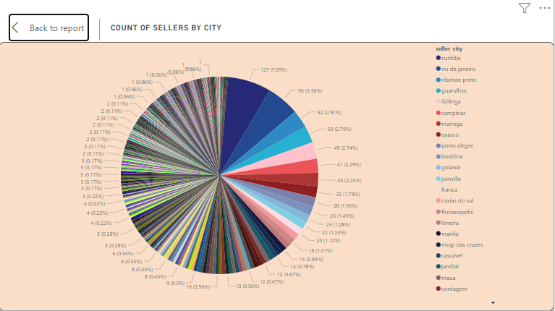

The image shows a pie chart titled "Count of Sellers by City." This chart provides a visual representation of the distribution of sellers across different cities. Here’s a detailed analysis:

**Overview**

* The pie chart shows the proportion of sellers from various cities.
* Each segment of the pie chart represents a city and the corresponding number of sellers.
* The chart includes a legend indicating the cities and their associated colors.

The image shows a pie chart titled "Count of Sellers by City." This chart provides a visual representation of the distribution of sellers across different cities. Here’s a detailed analysis:

**Key Points**

1. **Curitiba:**
   * Sellers: 127
   * Percentage: 7.09%
   * Insight: Curitiba has the highest number of sellers, making up a significant portion of the total.
2. **Rio de Janeiro:**
   * Sellers: 96
   * Percentage: 5.36%
   * Insight: Rio de Janeiro follows Curitiba with a notable number of sellers.
3. **Ribeirao Preto:**
   * Sellers: 62
   * Percentage: 3.46%
   * Insight: This city also has a relatively high number of sellers.
4. **Guarulhos:**
   * Sellers: 50
   * Percentage: 2.79%
   * Insight: Guarulhos contributes a fair number of sellers to the overall count.
5. **Ibitinga:**
   * Sellers: 40
   * Percentage: 2.23%
   * Insight: Ibitinga has a moderate number of sellers.
6. **Campinas:**
   * Sellers: 39
   * Percentage: 2.18%
   * Insight: Similar to Ibitinga, Campinas has a comparable number of sellers.
7. **Maringa:**
   * Sellers: 34
   * Percentage: 1.90%
   * Insight: Maringa shows a smaller yet significant presence of sellers.
8. **Osasco:**
   * Sellers: 32
   * Percentage: 1.79%
   * Insight: Osasco has a similar number of sellers as Maringa.
9. **Porto Alegre:**
   * Sellers: 31
   * Percentage: 1.73%
   * Insight: Porto Alegre also shows a small but notable number of sellers.
10. **Londrina:**
    * Sellers: 28
    * Percentage: 1.56%
    * Insight: Londrina has fewer sellers but is still represented in the chart.

**Additional Cities:**

* The remaining cities each contribute less than 1.5% of the total sellers.
* Cities such as Joinville, Goiania, Franca, Caxias do Sul, Florianopolis, Limeira, Marilia, Mogi das Cruzes, Cascavel, Jundiai, Maua, and Contagem each have sellers ranging from 1 to 27, contributing smaller segments to the pie chart.

**Analysis:**

1. **Major Contributors:**
   * Curitiba, Rio de Janeiro, Ribeirao Preto, and Guarulhos are the major contributors, collectively accounting for a substantial portion of the total sellers.
2. **Diverse Distribution:**
   * The distribution of sellers is quite diverse, with many cities contributing smaller portions.
3. **Strategic Insights:**
   * Businesses can target marketing and sales efforts in cities with higher seller counts to leverage existing networks.
   * Understanding the distribution can help in planning logistics, support, and regional promotions.

**Conclusion:**

The pie chart provides a clear visual representation of the distribution of sellers across different cities. It highlights key cities with significant seller presence and shows the diversity of seller locations. This information can be crucial for strategic planning and decision-making in business operations.

**Question Statement:**

8. Create a dynamic visual that compares the number of delayed orders to the number of orders received earlier for each month. Utilize the drill through the cross-report feature to provide a detailed analysis of late and on-time deliveries.

**Visualization:**

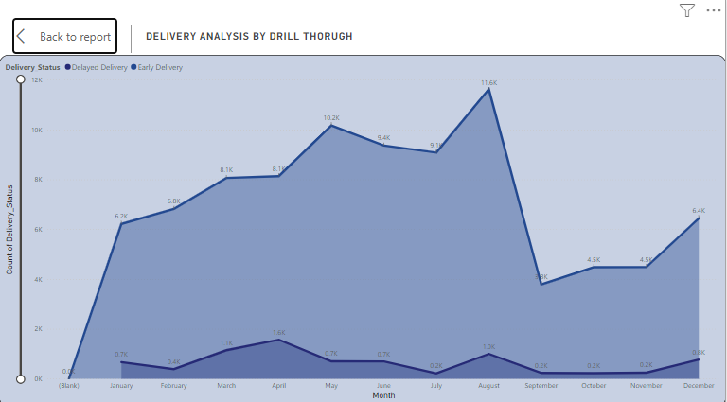

**Explanation:**

To create a dynamic visual in Power BI that compares the number of delayed orders to the number of orders received earlier for each month, and to provide a detailed analysis using the drill-through feature, follow below steps:

Ensure you have a dataset that includes information about orders, including order dates, status (delayed or on-time), and other relevant metrics.

In Power BI Desktop, create measures to calculate the number of delayed orders and earlier (on-time) orders for each month. You can use DAX (Data Analysis Expressions) to define these measures based on your dataset.

Here are the key points for creating a dynamic Power BI visual comparing delayed and earlier orders, with drill-through functionality:

1. **Dataset Preparation**:
   * Ensure your dataset includes order dates, statuses (delayed or on-time), and other relevant metrics.
2. **Measure Creation**:
   * **Delayed Orders**: Create a measure to count the number of delayed orders.
   * **Earlier Orders**: Create a measure to count the number of on-time orders.
3. **Line Chart Visualization**:
   * **Add Line Chart**: In Power BI Desktop, drag the Month field to the Axis and the Delayed Orders and Earlier Orders measures to the Values section.
4. **Chart Customization**:
   * **Format the Chart**: Adjust the chart axes, labels, and legend for clarity and better readability.
5. **Drill-Through Feature**:
   * **Enable Drill-Through**: Right-click on the chart, select "Drill Through" > "New Drill Through" to allow detailed analysis when interacting with specific data points.
6. **Trend Analysis**:
   * **Identify Trends**: Analyze the chart to compare delayed and earlier orders across months. Look for exceptional performance (e.g., August with high efficiency) and increased delays during peak periods (e.g., December and January).
7. **Operational Insights**:
   * **Address Bottlenecks**: Use insights to identify and address operational issues, optimize resource allocation, and implement strategies to reduce delays during peak seasons.
8. **Seasonal Variations**:
   * **Analyze Seasonal Effects**: Note higher delayed orders during peak times (e.g., holiday seasons) and adjust strategies accordingly.

**Chart Overview**

* **X-Axis:** Represents the months from January to December.
* **Y-Axis:** Represents the count of delivery statuses, with values ranging from 0 to 12K.
* **Categories:**
  + **Delayed Delivery:** Represented by a darker blue area.
  + **Early Delivery:** Represented by a lighter blue area above the dark blue area.

**Key Points**

1. **January:**
   * Delayed: 0.7K
   * Early: 6.1K
   * **Insight:** January shows a higher number of early deliveries compared to delayed ones.
2. **February:**
   * Delayed: 1.1K
   * Early: 6.8K
   * **Insight:** February also exhibits a higher count of early deliveries.
3. **March:**
   * Delayed: 1.6K
   * Early: 7.7K
   * **Insight:** March follows the trend with early deliveries exceeding delayed ones.
4. **April:**
   * Delayed: 0.7K
   * Early: 8.1K
   * **Insight:** A significant number of early deliveries with relatively low delayed ones.
5. **May:**
   * Delayed: 0.7K
   * Early: 10.2K
   * **Insight:** May sees the highest number of early deliveries so far.
6. **June:**
   * Delayed: 0.7K
   * Early: 9.4K
   * **Insight:** A slight decrease in early deliveries compared to May.
7. **July:**
   * Delayed: 0.7K
   * Early: 11.6K
   * **Insight:** July peaks with the highest number of early deliveries.
8. **August:**
   * Delayed: 1.0K
   * Early: 8.1K
   * **Insight:** A notable number of early deliveries with an increase in delayed ones.
9. **September:**
   * Delayed: 0K
   * Early: 3.2K
   * **Insight:** September has a sharp drop in early deliveries.
10. **October:**
    * Delayed: 0.2K
    * Early: 4.5K
    * **Insight:** Slight recovery in early deliveries with minimal delays.
11. **November:**
    * Delayed: 0.2K
    * Early: 4.5K
    * **Insight:** Stable early deliveries similar to October.
12. **December:**
    * Delayed: 0K
    * Early: 6.4K
    * **Insight:** December sees a significant rise in early deliveries.

**Observations**

* **Trends:**
  + The early deliveries consistently outnumber delayed deliveries throughout the year.
  + July has the highest number of early deliveries at 11.6K.
  + September shows the lowest early deliveries at 3.2K, indicating a potential issue or seasonal trend.
  + Delayed deliveries are relatively low across all months, peaking slightly in March and August.
* **Seasonal Variations:**
  + There is a noticeable peak in early deliveries in July.
  + A significant drop in early deliveries in September.
  + Gradual recovery of early deliveries towards the end of the year.

**Strategic Insights**

* **Operational Efficiency:**
  + The high number of early deliveries suggests effective logistics and supply chain management for most of the year.
  + Addressing the drop in September can help in maintaining consistency.
* **Customer Satisfaction:**
  + High early delivery rates likely contribute to higher customer satisfaction.
  + Ensuring consistent delivery performance, especially during the lower months, can improve overall service quality.
* **Resource Allocation:**
  + Insights from the chart can guide resource allocation, focusing on maintaining early delivery trends and reducing delays.

**Conclusion**

The area chart effectively illustrates the delivery performance, highlighting the distinction between early and delayed deliveries across different months. The insights drawn from the trends and variations can help in strategic planning, improving operational efficiency, and enhancing customer satisfaction.